Open Circular Arcs
# Source: AI Source: Provided by: [Data Path: Persons Table -> ID Column: 1, Name_En Column: Motasem Essam] -> From: [ChatGPT] on [7/25/2026]
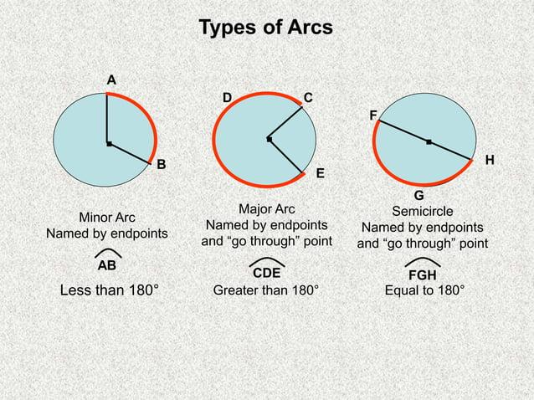
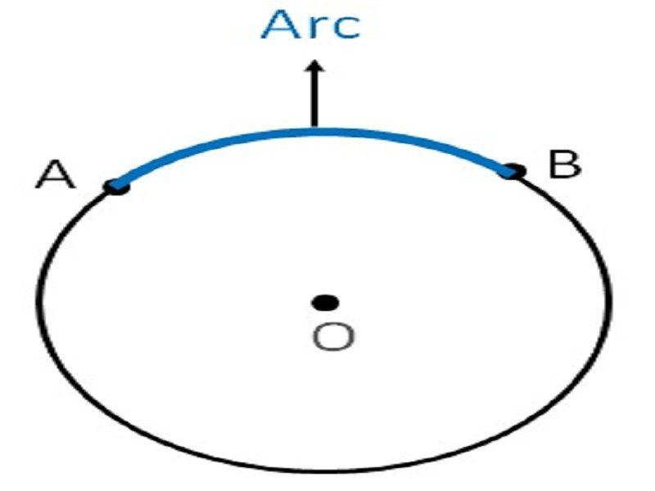
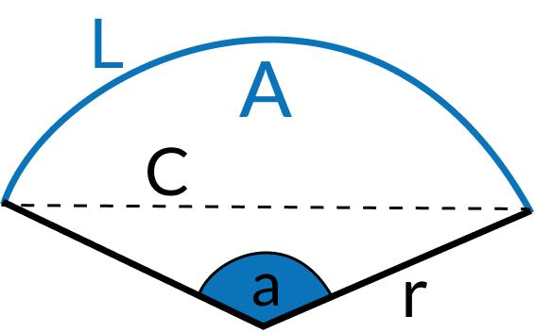
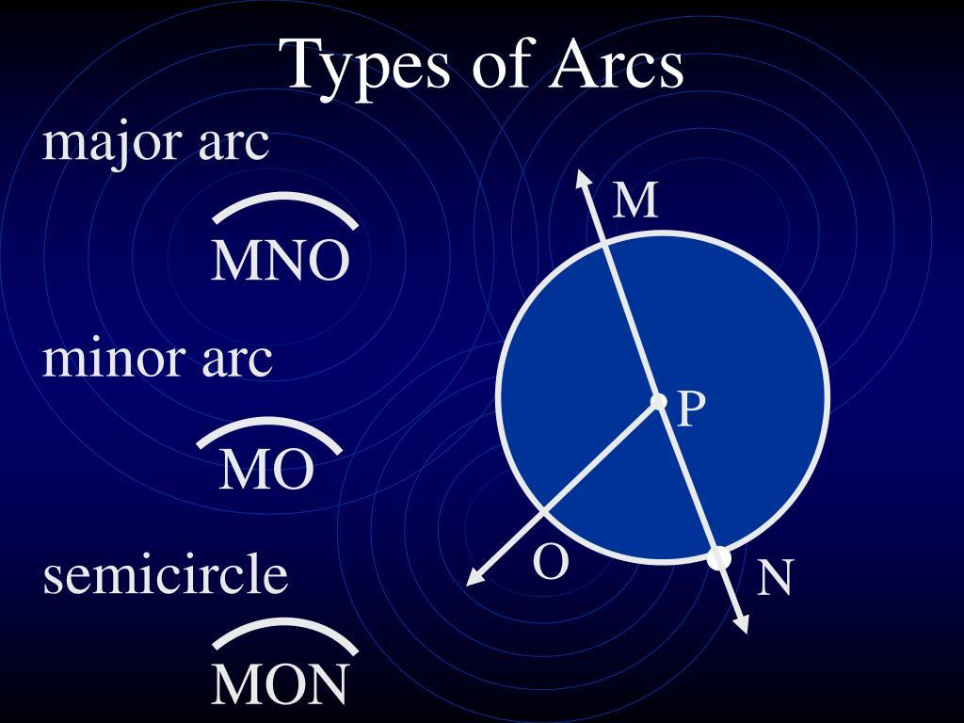
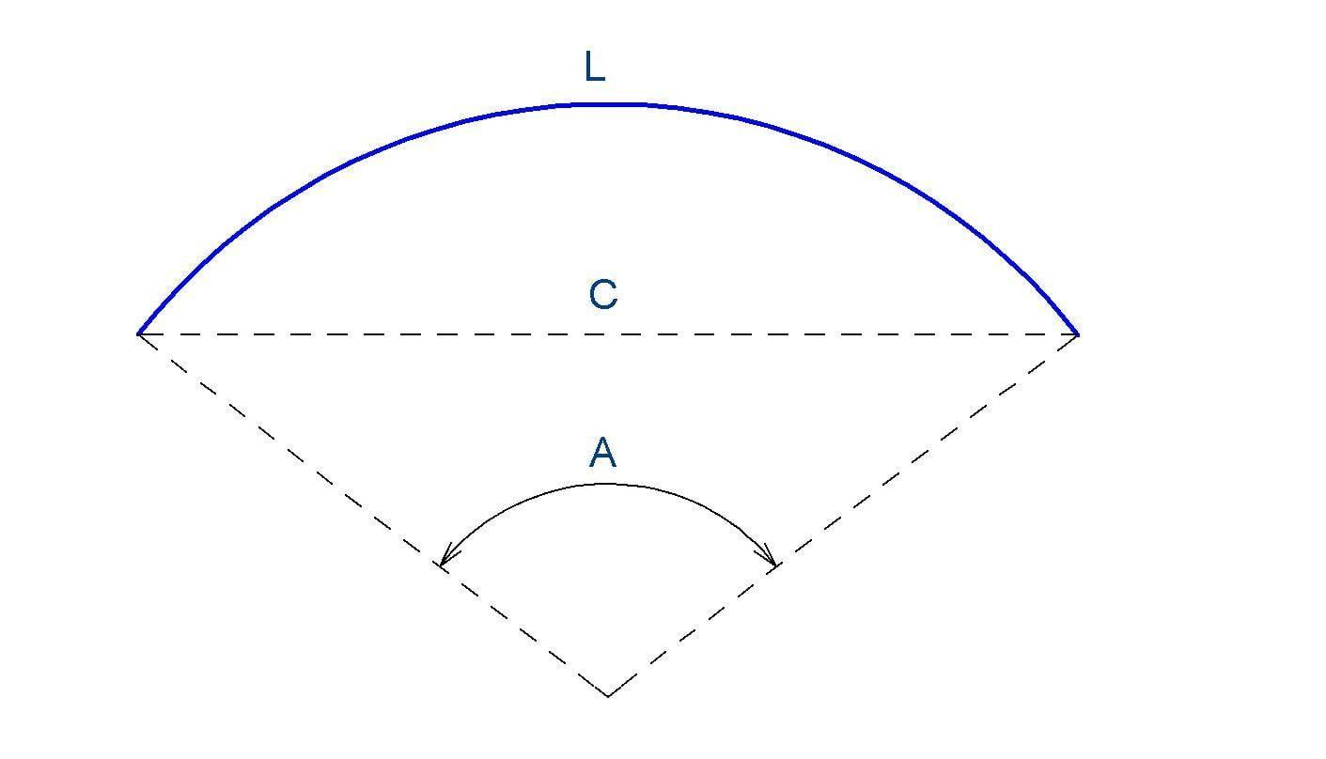

Definition
# Source: AI Source: Provided by: [Data Path: Persons Table -> ID Column: 1, Name_En Column: Motasem Essam] -> From: [ChatGPT] on [7/25/2026]
An Open Circular Arc is an open curved shape formed by a continuous portion of a circle, with two distinct endpoints.
$$\boxed{\text{Open Circular Arc}=\text{Part of a Circle}+\text{Continuous Curvature}+\text{Two Open Endpoints}}$$
Unlike a circle, an arc does not form a closed boundary and therefore does not enclose a region by itself.

Characteristics
# Source: AI Source: Provided by: [Data Path: Persons Table -> ID Column: 1, Name_En Column: Motasem Essam] -> From: [ChatGPT] on [7/25/2026]
An Open Circular Arc:
- Is open.
- Is part of a circle.
- Has two distinct endpoints.
- Has a constant radius.
- Has constant curvature.
- Does not enclose an area by itself.
- Can subtend an angle less than, equal to, or greater than (180^\circ).
- Can be part of a larger closed shape.

Types of Open Circular Arcs

1. Minor Circular Arc
# Source: AI Source: Provided by: [Data Path: Persons Table -> ID Column: 1, Name_En Column: Motasem Essam] -> From: [ChatGPT] on [7/25/2026]
A minor arc is an arc whose central angle is less than ${180}^{∘}$.
$$\boxed{0^{∘}<θ<{180}^{∘}}$$
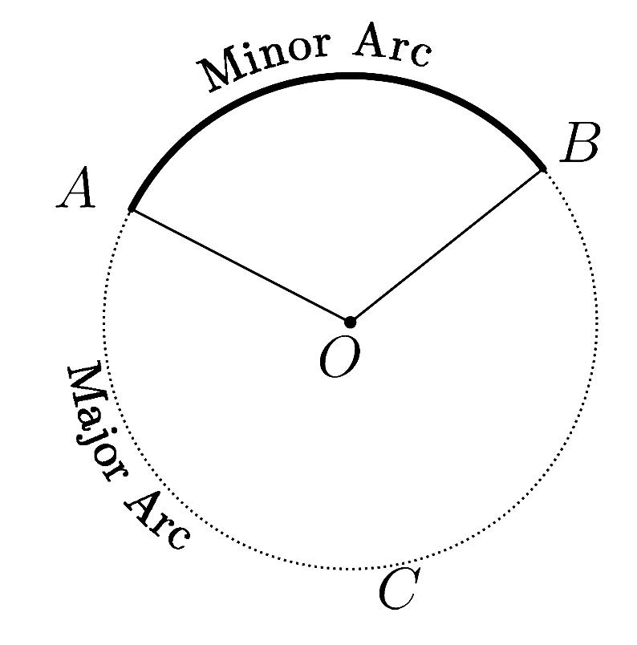
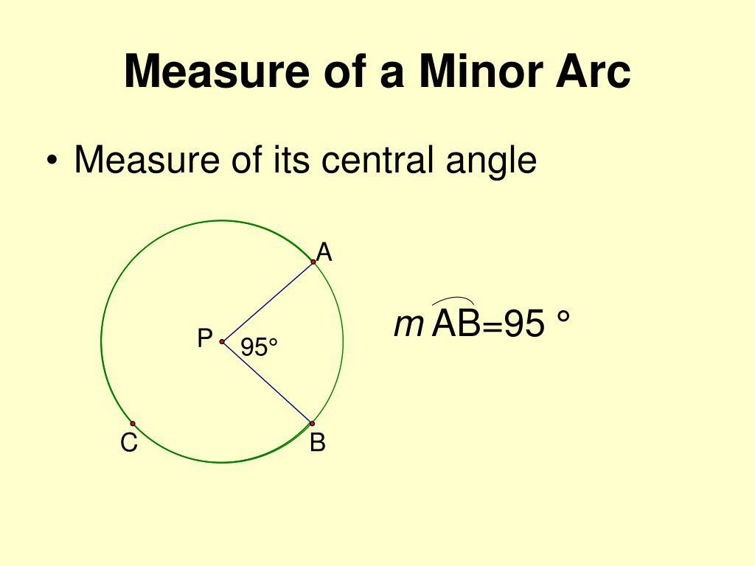
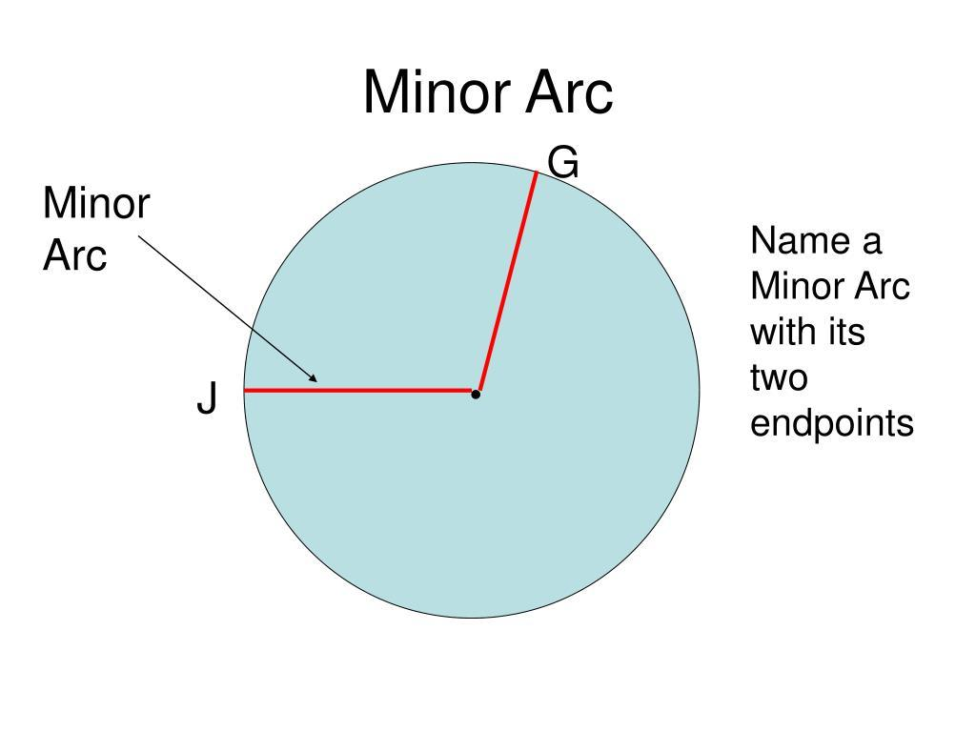
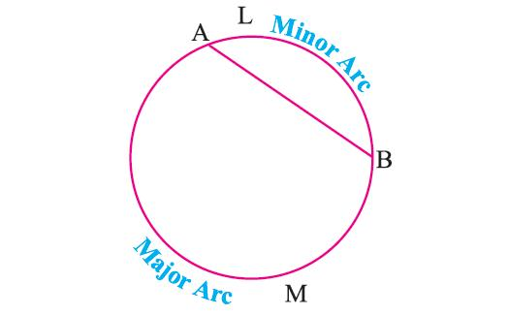
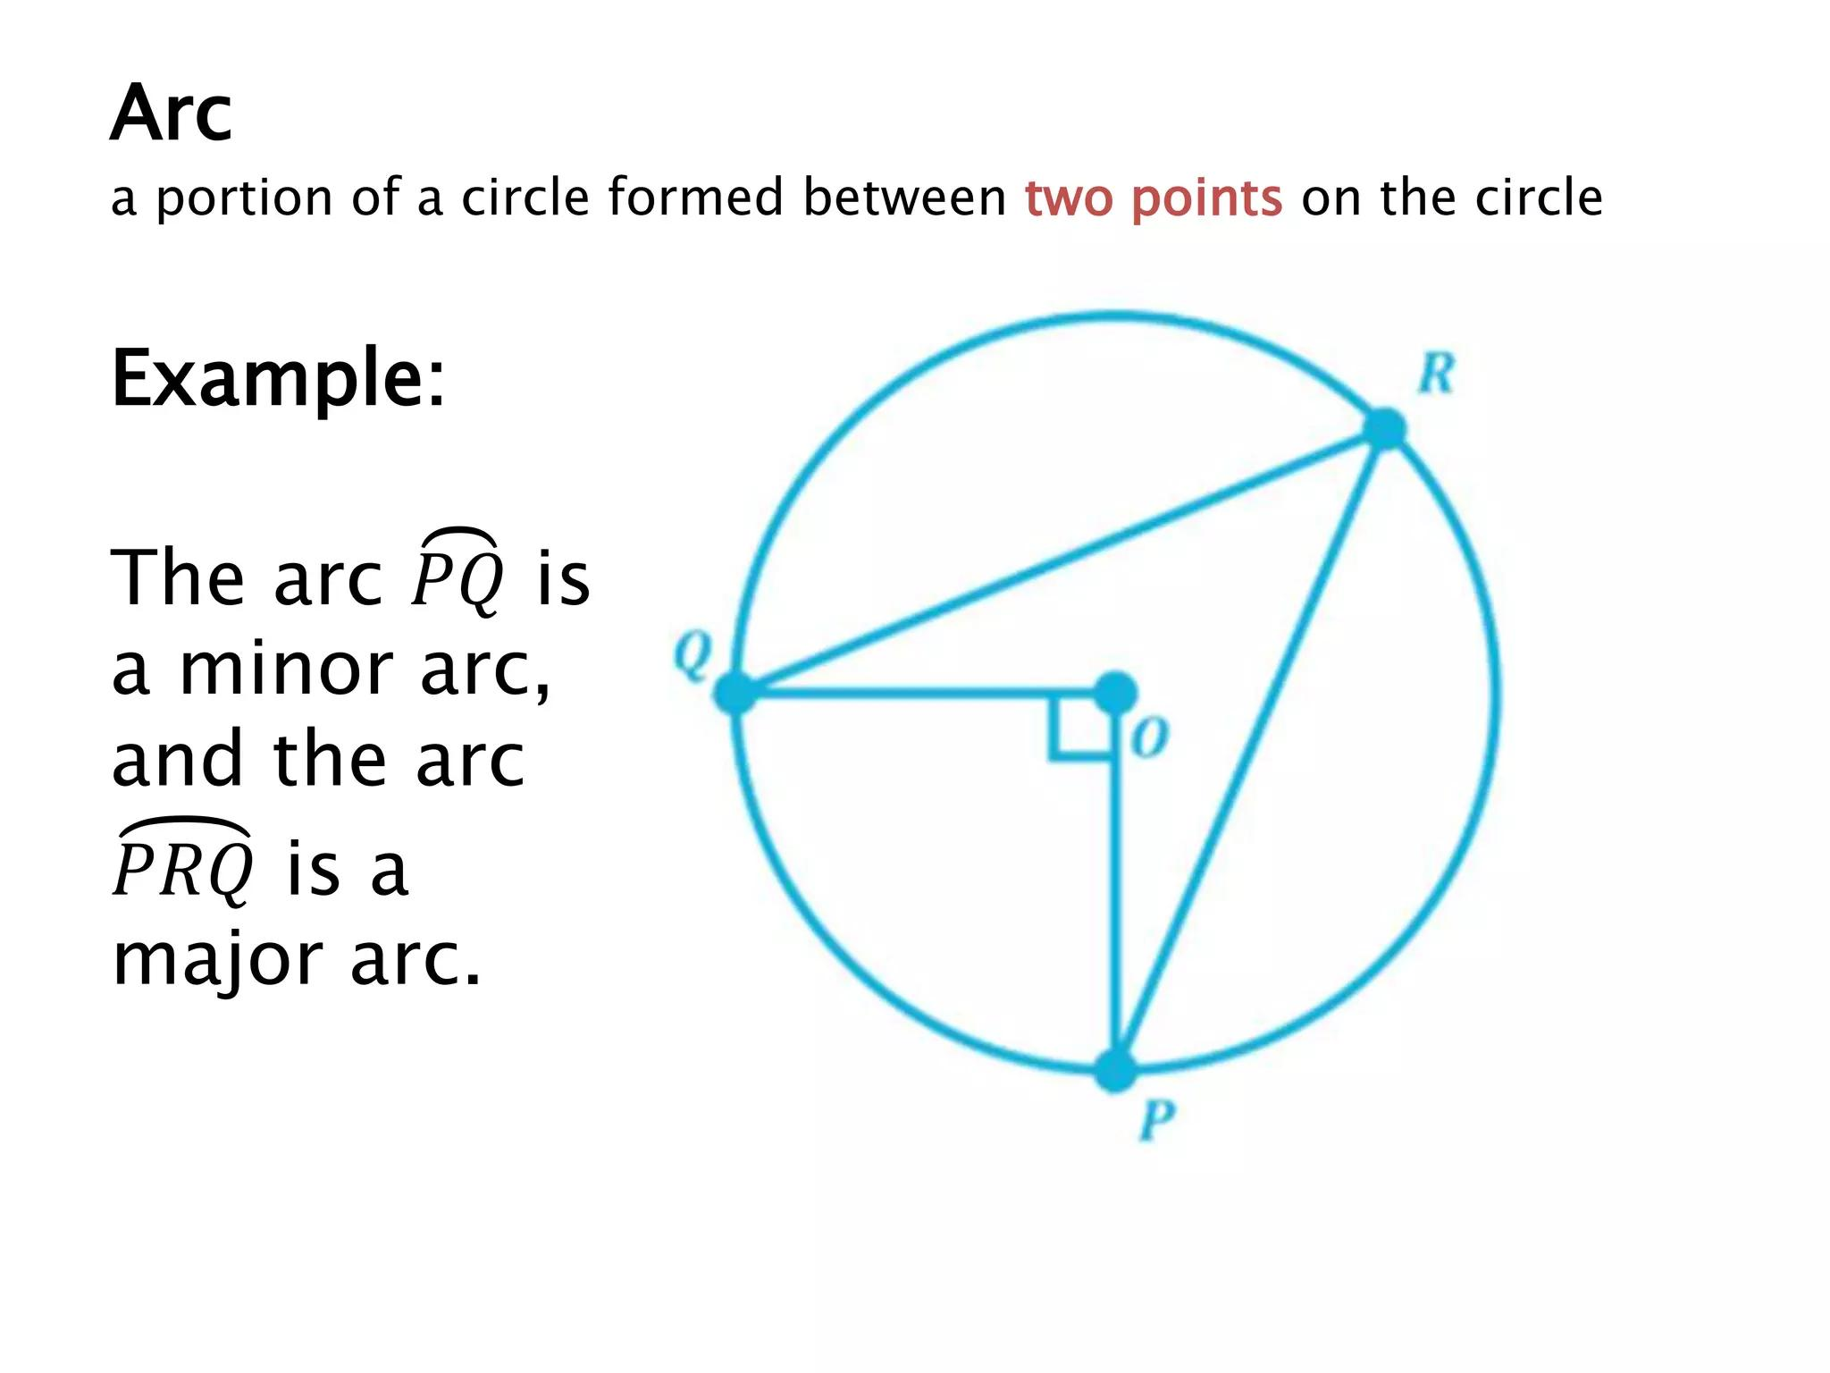
It represents the shorter path between two points on a circle.

2. Semicircular Arc
# Source: AI Source: Provided by: [Data Path: Persons Table -> ID Column: 1, Name_En Column: Motasem Essam] -> From: [ChatGPT] on [7/25/2026]
A semicircular arc represents exactly half of a circle.
$$\boxed{θ={180}^{∘}}$$
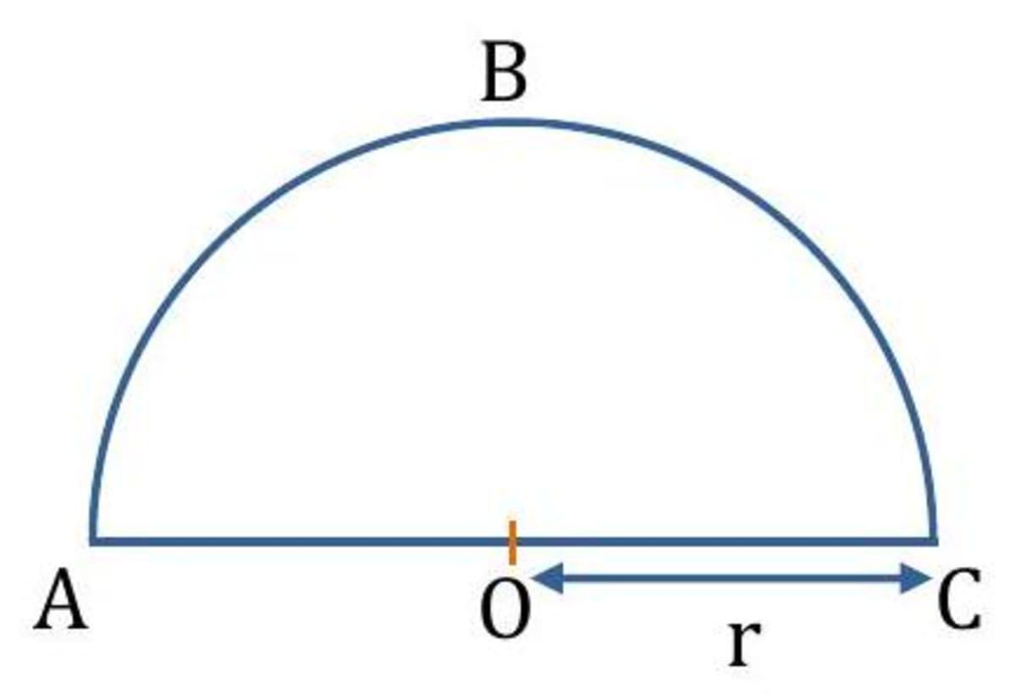
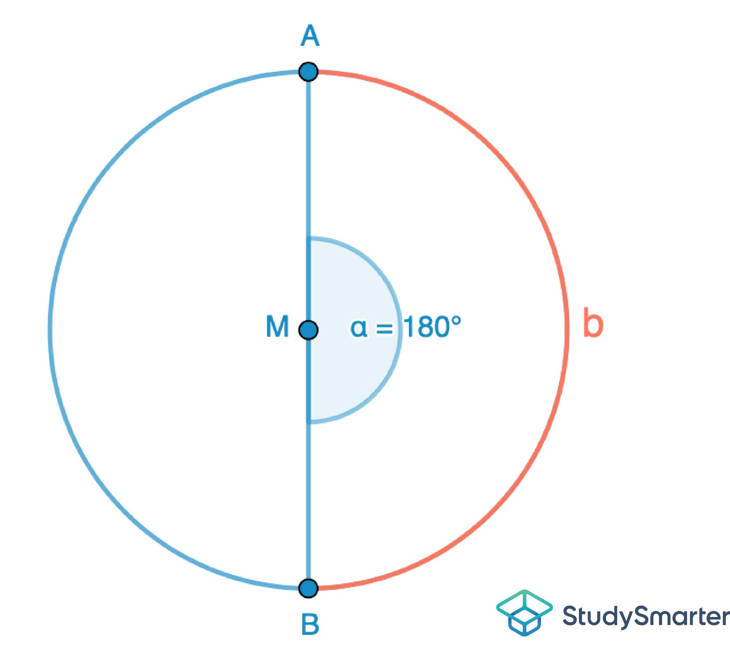
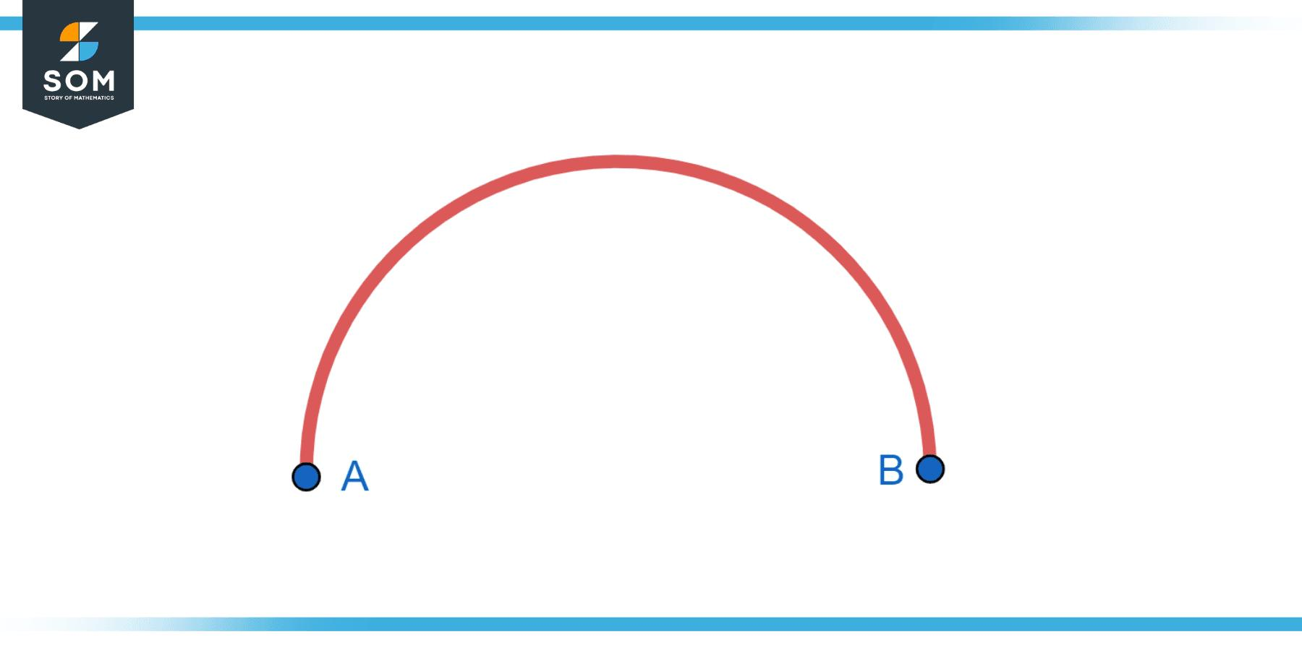
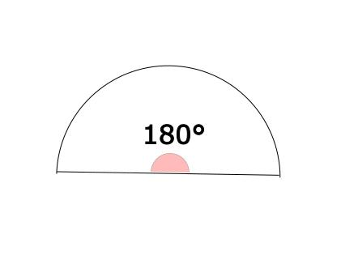
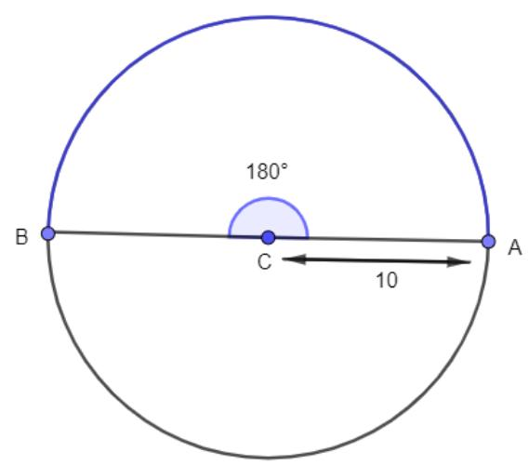
Its endpoints are the endpoints of a diameter.

3. Major Circular Arc
# Source: AI Source: Provided by: [Data Path: Persons Table -> ID Column: 1, Name_En Column: Motasem Essam] -> From: [ChatGPT] on [7/25/2026]
A major arc has a central angle greater than ${180}^{∘}$ but less than ${360}^{∘}$.
$$\boxed{{180}^{∘}<θ<{360}^{∘}}$$
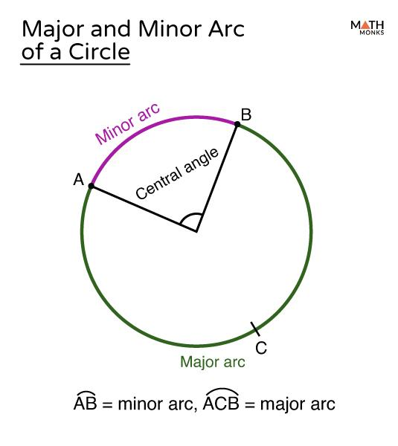
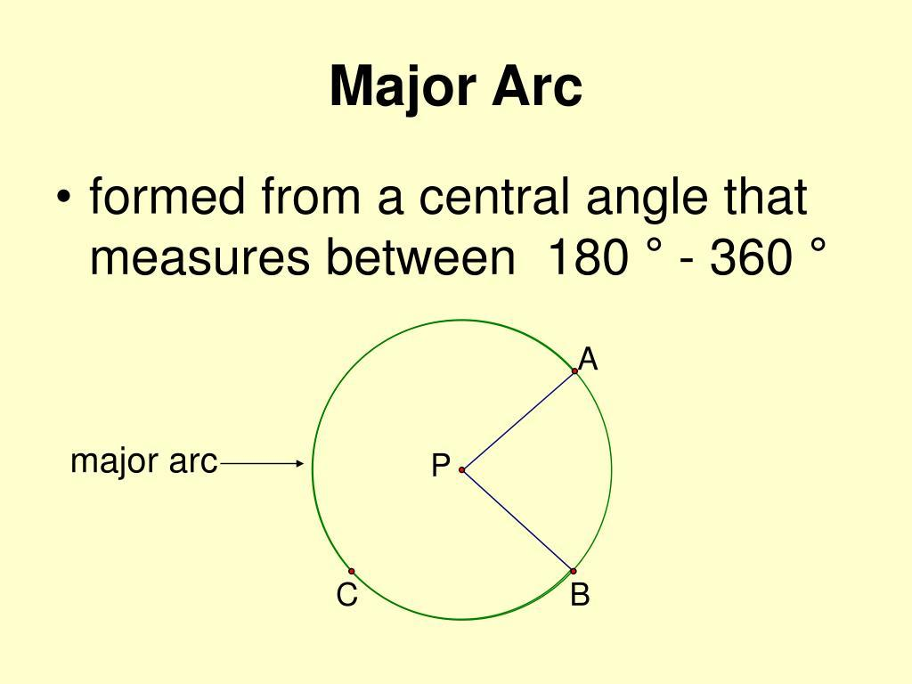
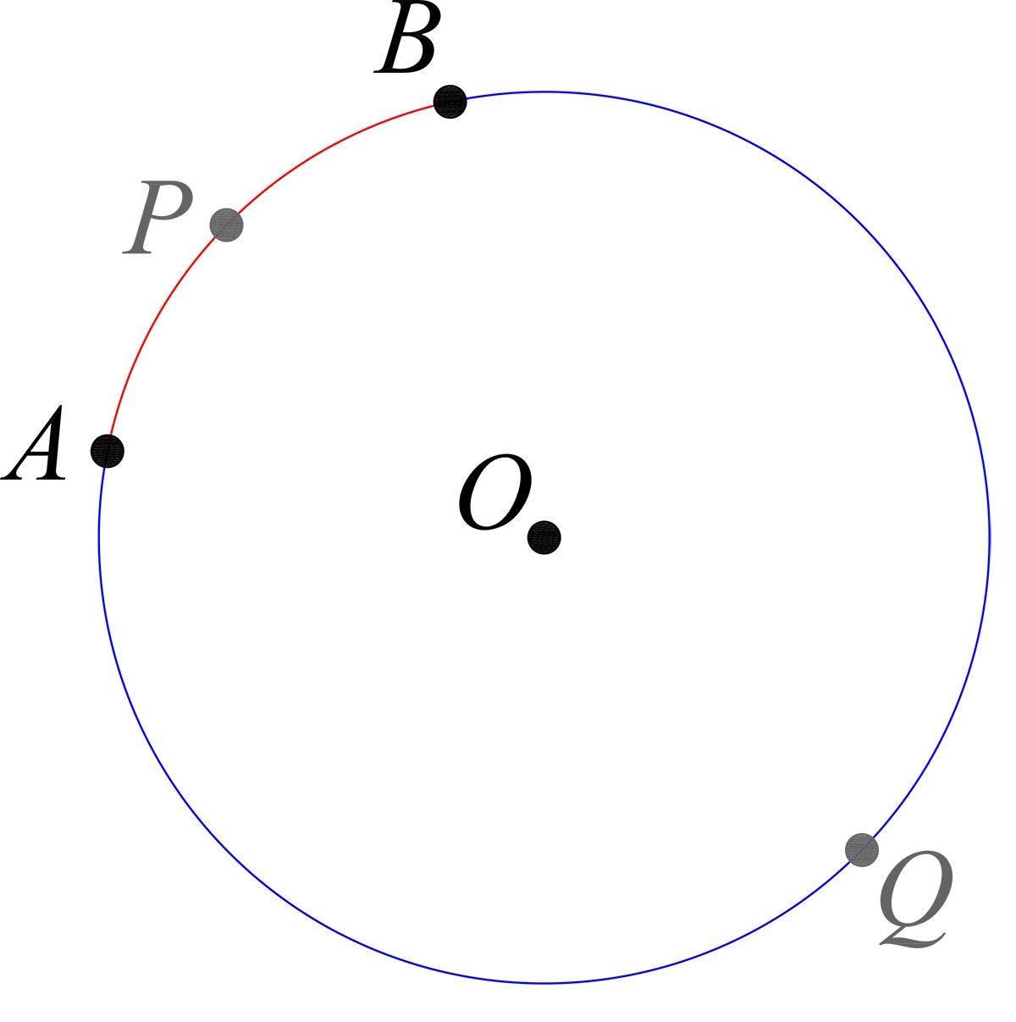
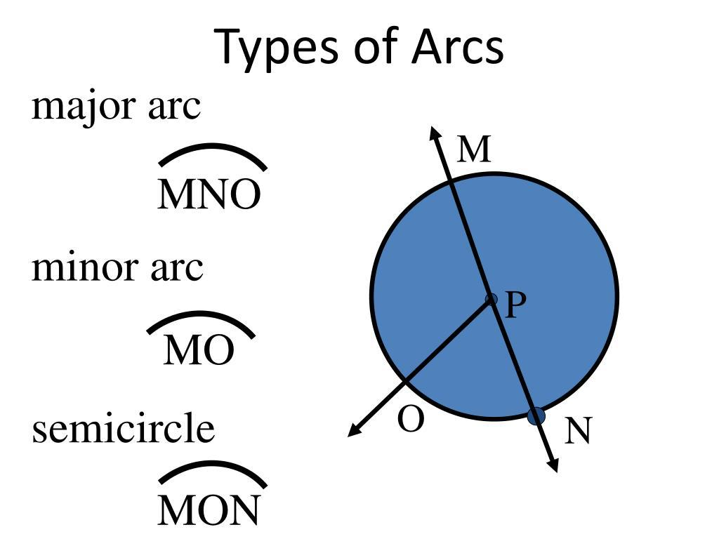
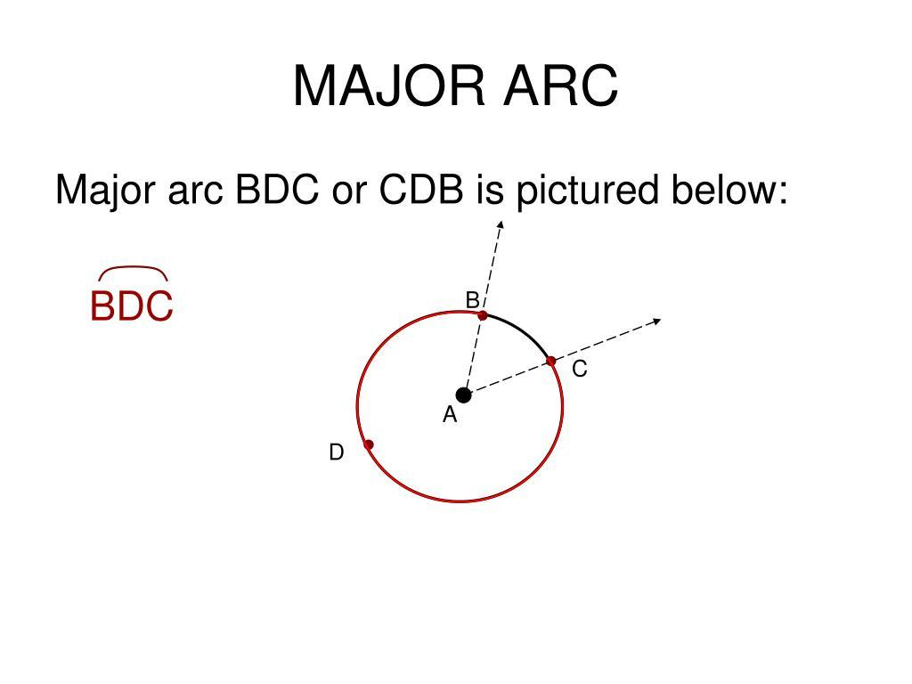
It represents the longer path between two points on a circle.

4. Quarter-Circular Arc
# Source: AI Source: Provided by: [Data Path: Persons Table -> ID Column: 1, Name_En Column: Motasem Essam] -> From: [ChatGPT] on [7/25/2026]
A quarter-circular arc represents one quarter of a circle.
$$\boxed{θ={90}^{∘}}$$
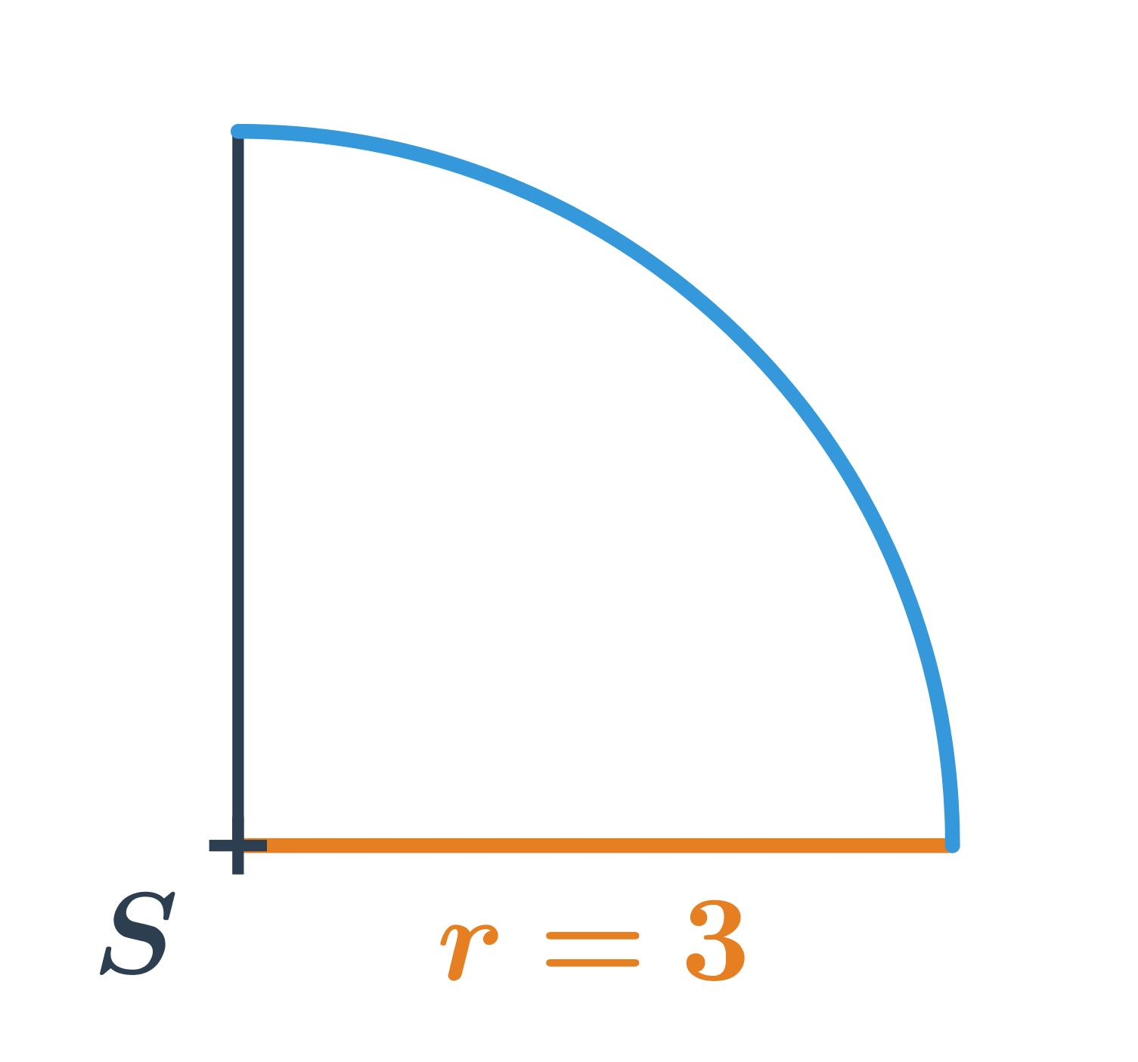
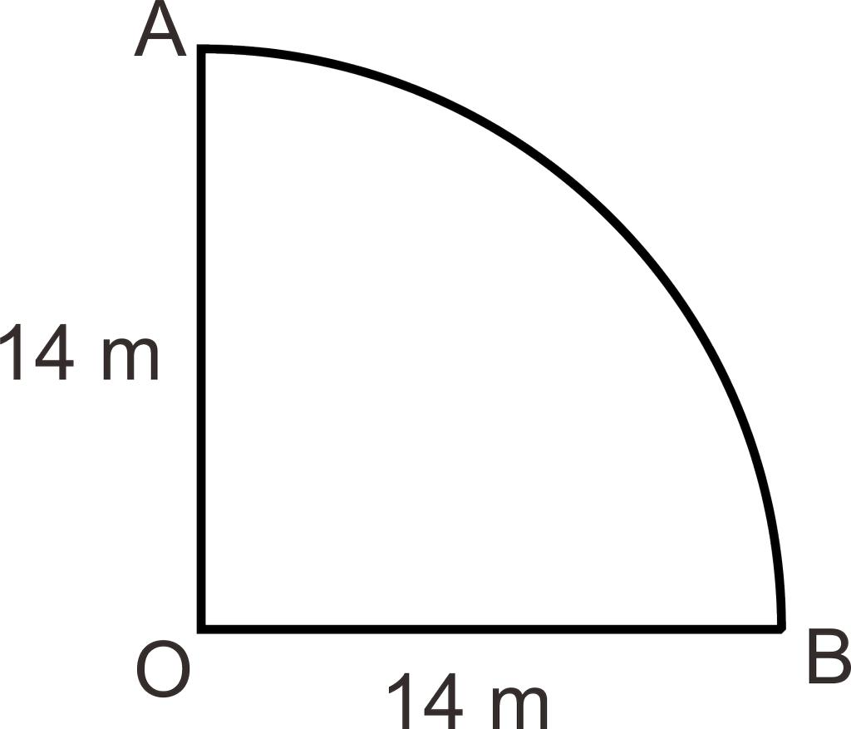
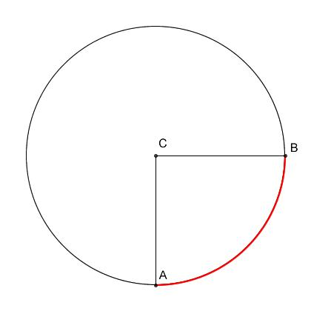
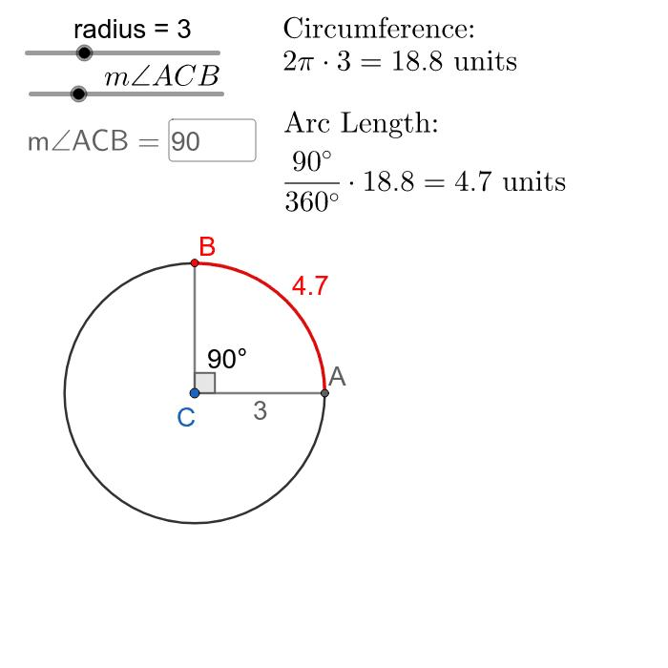
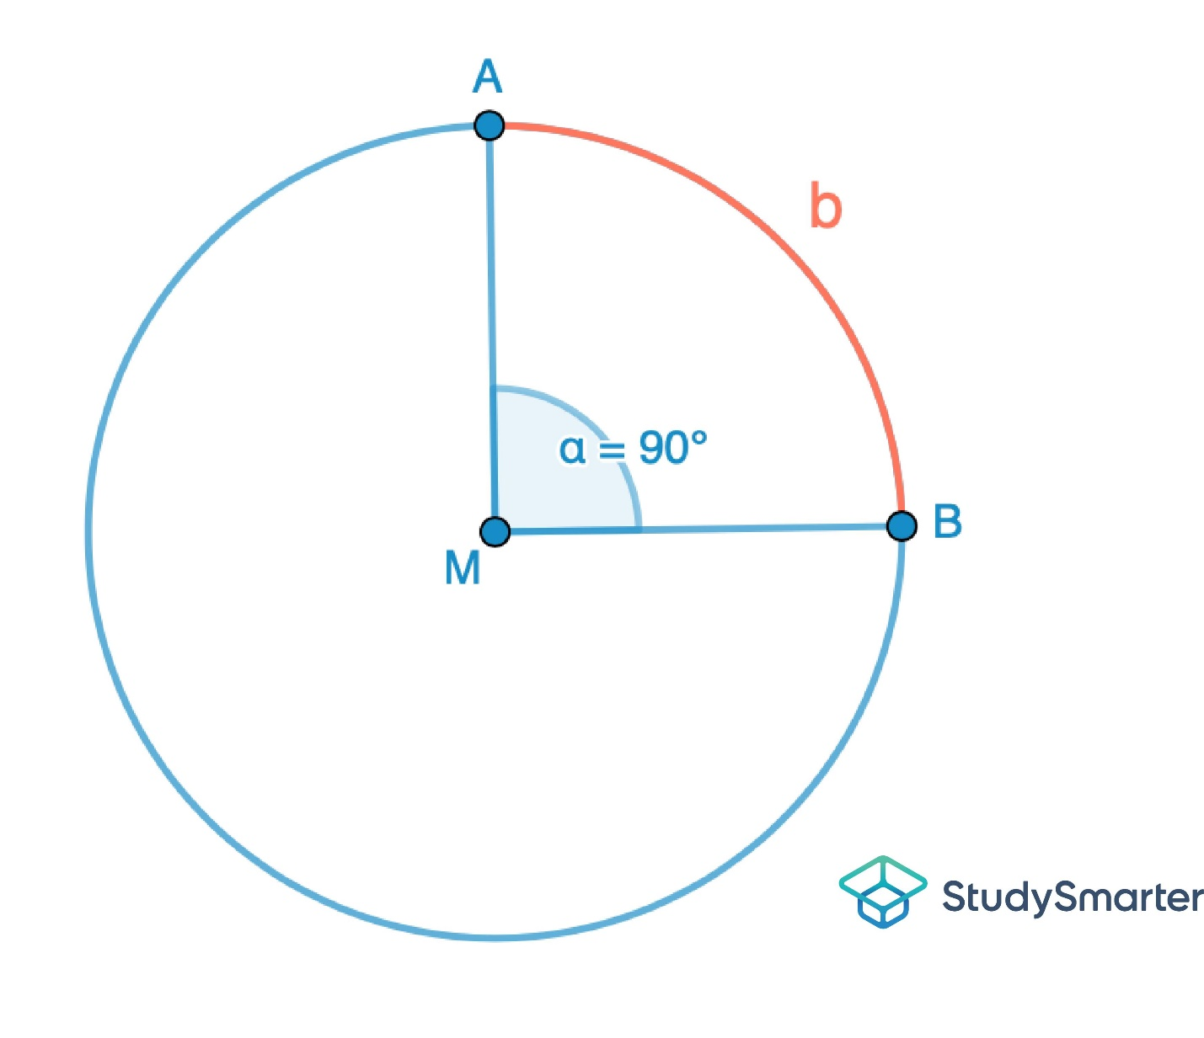

5. Three-Quarter Circular Arc
# Source: AI Source: Provided by: [Data Path: Persons Table -> ID Column: 1, Name_En Column: Motasem Essam] -> From: [ChatGPT] on [7/25/2026]
A three-quarter arc represents three quarters of a complete circle.
$$\boxed{θ={270}^{∘}}$$
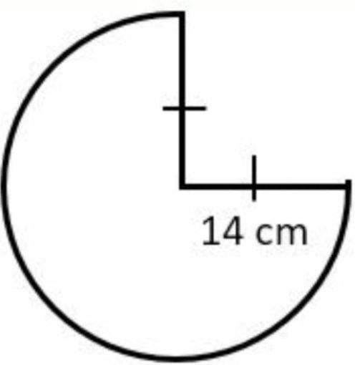
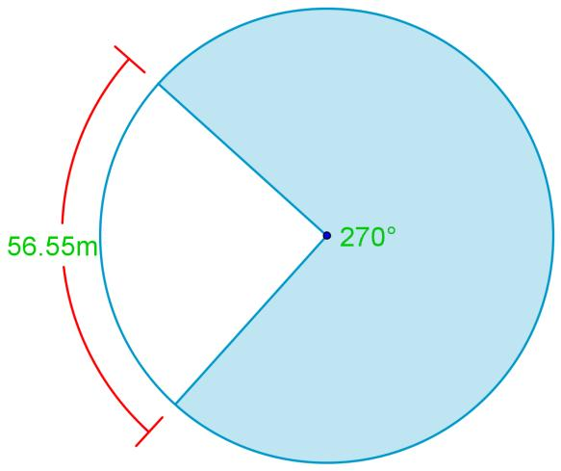

6. Short Circular Arc
# Source: AI Source: Provided by: [Data Path: Persons Table -> ID Column: 1, Name_En Column: Motasem Essam] -> From: [ChatGPT] on [7/25/2026]
A short circular arc covers a relatively small portion of the circle.
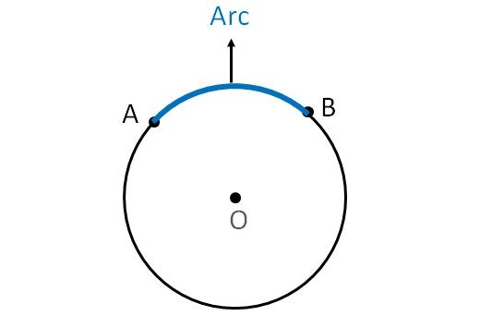
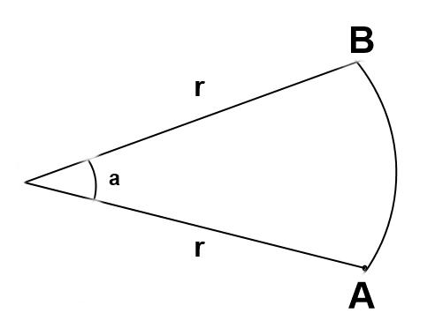
It is usually a minor arc with a relatively small central angle.

7. Long Circular Arc
# Source: AI Source: Provided by: [Data Path: Persons Table -> ID Column: 1, Name_En Column: Motasem Essam] -> From: [ChatGPT] on [7/25/2026]
A long circular arc covers a large portion of the circle while remaining open.
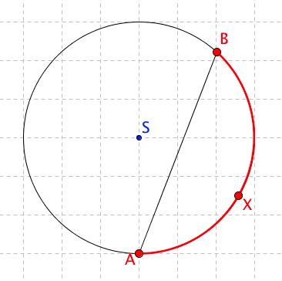
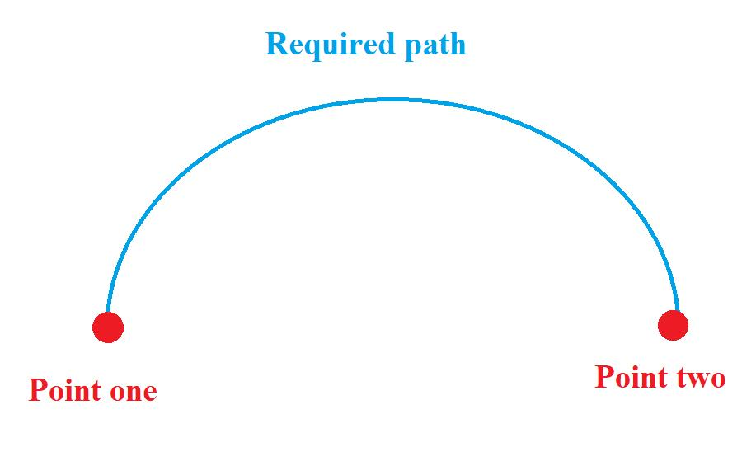
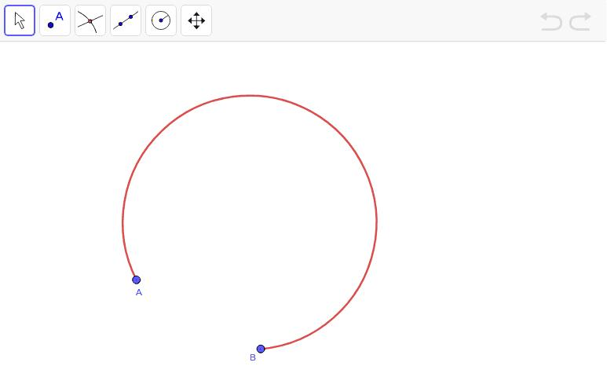
It may be a major arc or another large portion of a circle.

8. Open Circular Arc with Equal Endpoints
# Source: AI Source: Provided by: [Data Path: Persons Table -> ID Column: 1, Name_En Column: Motasem Essam] -> From: [ChatGPT] on [7/25/2026]
The arc itself remains open even though its endpoints may be positioned symmetrically around a diameter or axis.
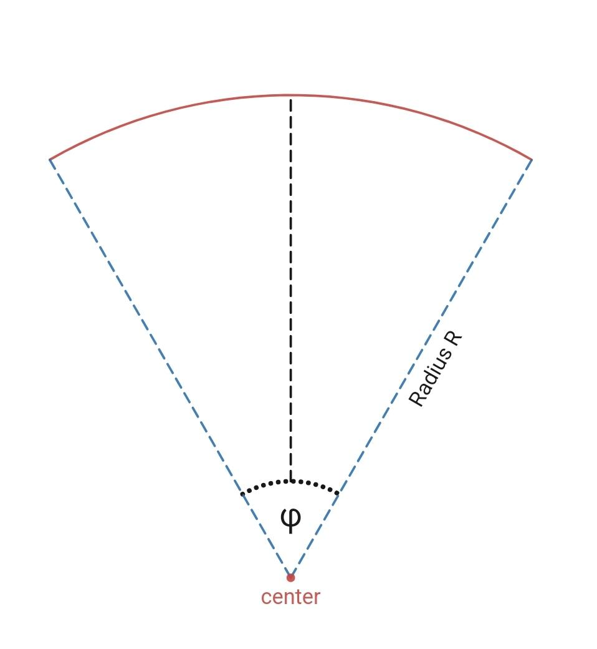
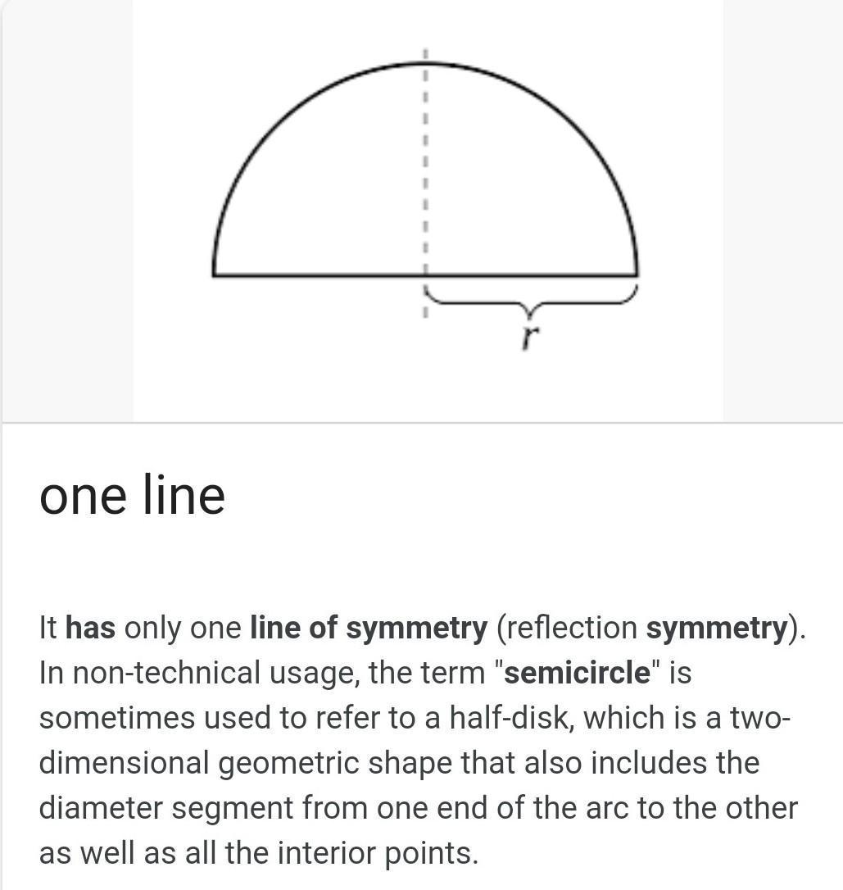
The important distinction is that symmetry does not make an arc closed.

9. Open Circular Arc Segment
# Source: AI Source: Provided by: [Data Path: Persons Table -> ID Column: 1, Name_En Column: Motasem Essam] -> From: [ChatGPT] on [7/25/2026]
A circular arc can be used as one boundary component of a larger shape.
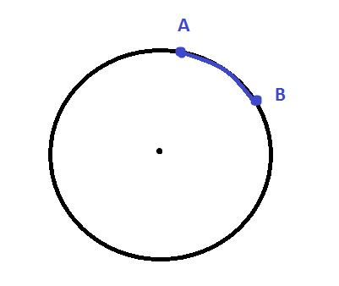
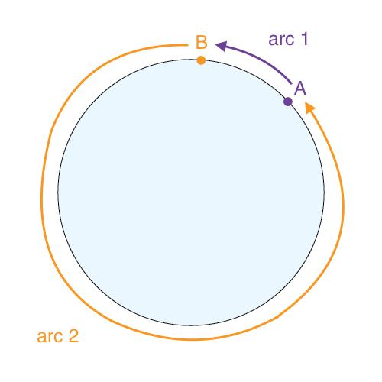
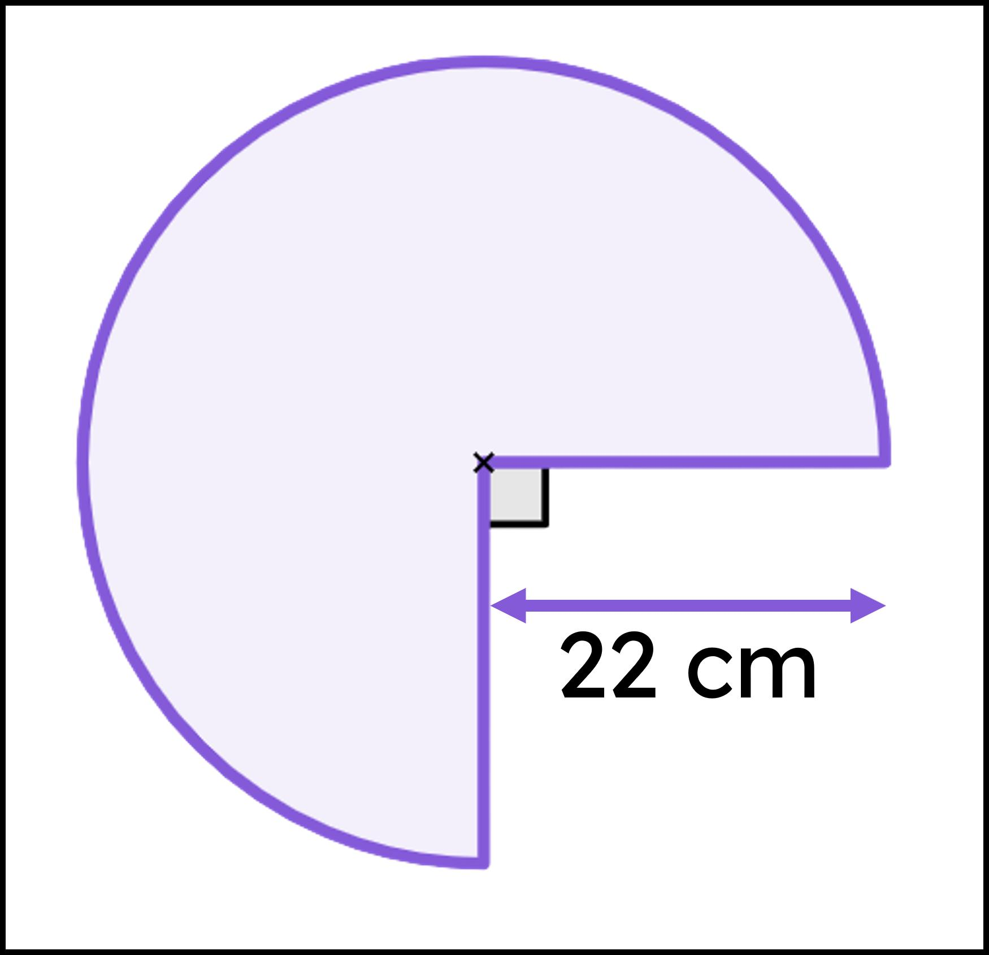
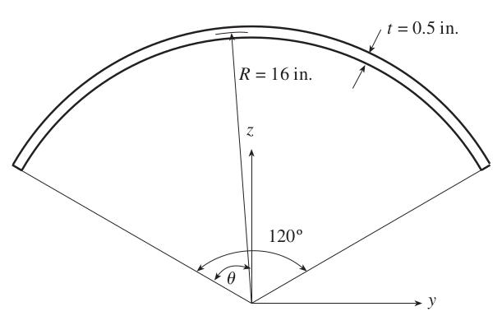
For example, a circular arc may later be connected to straight segments to form a closed mixed shape.

Arc Length
# Source: AI Source: Provided by: [Data Path: Persons Table -> ID Column: 1, Name_En Column: Motasem Essam] -> From: [ChatGPT] on [7/25/2026]
For a circular arc with radius (r) and central angle (\theta) measured in radians:
$$\boxed{L=rθ}$$
If the angle is given in degrees:
$$\boxed{L=\frac{θ}{{360}^{∘}}\left(2πr\right)}$$

Open Circular Arc vs. Circle
# Source: AI Source: Provided by: [Data Path: Persons Table -> ID Column: 1, Name_En Column: Motasem Essam] -> From: [ChatGPT] on [7/25/2026]
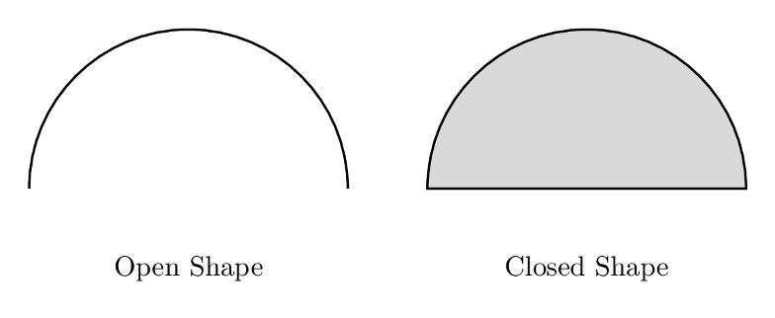
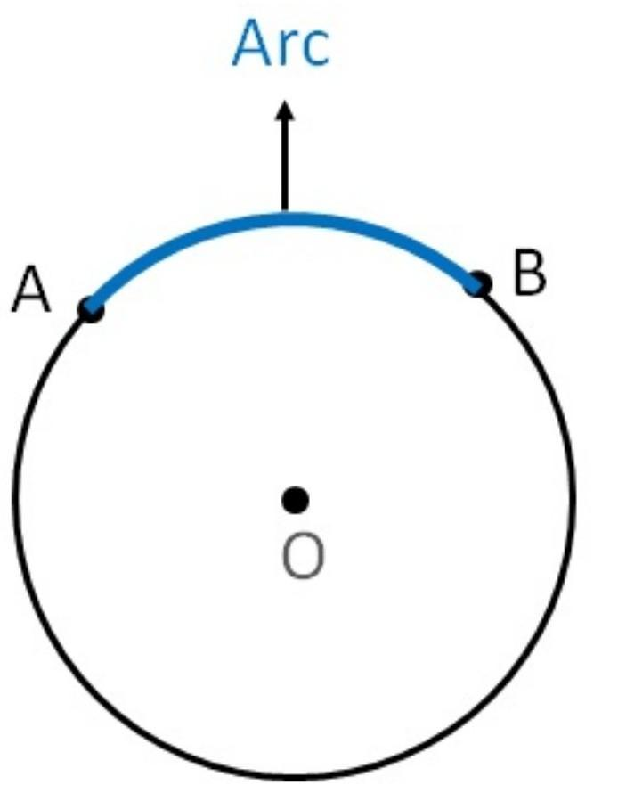
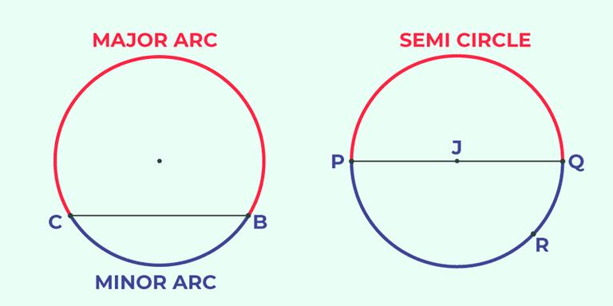
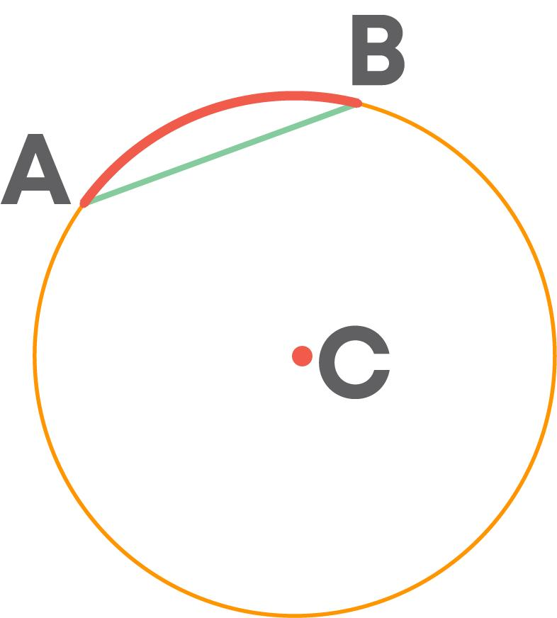
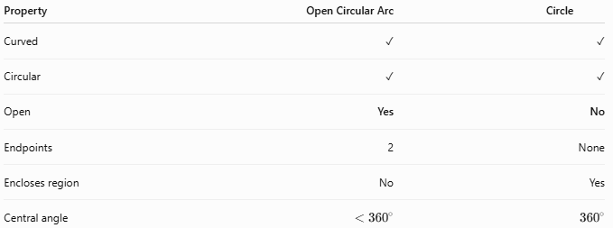
Property | Open Circular Arc | Circle
Curved | ✓ | ✓
Circular | ✓ | ✓
Open | Yes | No
Endpoints | 2 | None
Encloses region | No | Yes
Central angle | $$<{360}^{∘}$$ | $${360}^{∘}$$
The defining difference is closure.

Key Points
# Source: AI Source: Provided by: [Data Path: Persons Table -> ID Column: 1, Name_En Column: Motasem Essam] -> From: [ChatGPT] on [7/25/2026]
An Open Circular Arc is:
$$\boxed{\text{Open}+\text{Part of a Circle}+\text{Two Endpoints}}$$
It:
- Is a portion of a circle.
- Has exactly two endpoints.
- Has constant radius.
- Has constant curvature.
- Does not enclose an area by itself.
- Can be a minor, semicircular, or major arc.
- Can also be classified by its angular extent, such as ${90}^{∘}$, ${180}^{∘}$, or ${270}^{∘}$.
- Can serve as one component of a larger closed or mixed shape.
Most important distinction
$$\boxed{\text{Circular Arc}≠\text{Circle}}$$
A circular arc is open, while a circle is closed.

Conclusion
# Source: AI Source: Provided by: [Data Path: Persons Table -> ID Column: 1, Name_En Column: Motasem Essam] -> From: [ChatGPT] on [7/25/2026]
Open Circular Arcs are open curved shapes formed by portions of a circle. They are characterized by constant radius and curvature and two distinct endpoints. They can be classified according to their angular extent, length, and position within larger geometric or mixed shapes.

